2009 年 AMC 8 真题与解答
American Mathematics Competitions 8 · 中英双语
共 25 题，限时 40 分钟；单项选择题，每题 1 分，答错不扣分，满分 25 分。
内容来源：LIVE by Po-Shen Loh（live.poshenloh.com）历年 AMC 8 真题与解答，试题经美国数学协会（MAA）官方授权使用；本文档由本地整理生成，供个人学习使用，版权归原作者及 MAA 所有。
编排说明：第一部分为题目（先中文、后英文原题），第二部分为解答与答案，便于先做题后对答案。
第一部分 题目
第 1 题
布里奇特在杂货店买了一袋苹果。她把一半苹果给了安。然后她给了凯茜 3 个苹果，自己留下 4 个苹果。布里奇特买了多少个苹果？
（A）3 （B）4 （C）7 （D）11 （E）14
English
Bridget bought a bag of apples at the grocery store. She gave half of the apples to Ann. Then she gave Cassie 3 apples, keeping 4 apples for herself. How many apples did Bridget buy?
(A) 3 (B) 4 (C) 7 (D) 11 (E) 14
第 2 题
当地汽车经销店平均每卖出 4 辆跑车，就会卖出 7 辆轿车。经销店预测下个月会卖出 28 辆跑车。那么预计会卖出多少辆轿车？
（A）7 （B）32 （C）35 （D）49 （E）112
English
On average, for every 4 sports cars sold at the local car dealership, 7 sedans are sold. The dealership predicts that it will sell 28 sports cars next month. How many sedans does it expect to sell?
(A) 7 (B) 32 (C) 35 (D) 49 (E) 112
第 3 题
图像显示苏珊娜骑自行车的恒定速度。如果她以同样速度一共骑半小时，她会骑多少英里？
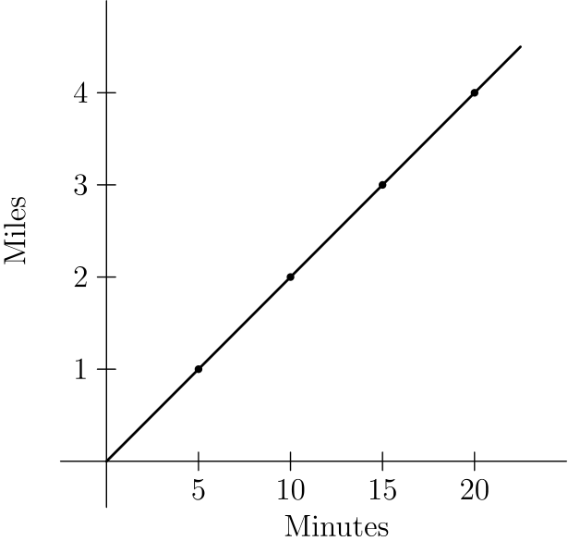
（A）5 （B）5.5 （C）6 （D）6.5 （E）7
English
The graph shows the constant rate at which Suzanna rides her bike. If she rides a total of half an hour at the same speed, how many miles will she have ridden?
(A) 5 (B) 5.5 (C) 6 (D) 6.5 (E) 7
第 4 题
下面显示的五块拼片可以拼成下方五个图形中的四个。哪一个图形<b>不能</b>拼成？
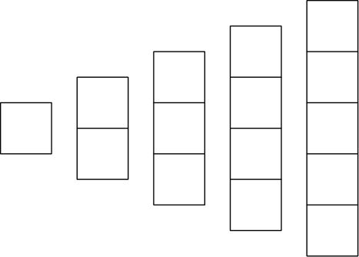
（A）<img src="/amc8/2009/4a.svg" style="max-height: 10rem"/> （B）<img src="/amc8/2009/4b.svg" style="max-height: 10rem"/> （C）<img src="/amc8/2009/4c.svg" style="max-height: 10rem"/> （D）<img src="/amc8/2009/4d.svg" style="max-height: 10rem"/> （E）<img src="/amc8/2009/4e.svg" style="max-height: 10rem"/>
English
The five pieces shown below can be arranged to form four of the five figures below. Which figure <b>cannot</b> be formed?
(A) <img src="/amc8/2009/4a.svg" style="max-height: 10rem"/> (B) <img src="/amc8/2009/4b.svg" style="max-height: 10rem"/> (C) <img src="/amc8/2009/4c.svg" style="max-height: 10rem"/> (D) <img src="/amc8/2009/4d.svg" style="max-height: 10rem"/> (E) <img src="/amc8/2009/4e.svg" style="max-height: 10rem"/>
第 5 题
一个数列以 1、2、3 开始。数列的第四个数是前三个数之和，即 1 + 2 + 3 = 6。同样地，第四个数之后的每个数都是它前面三个数之和。这个数列的第八个数是多少？
（A）11 （B）20 （C）37 （D）68 （E）99
English
A sequence of numbers starts with 1, 2, and 3. The fourth number of the sequence is the sum of the previous three numbers in the sequence: 1 + 2 + 3 = 6. In the same way, every number after the fourth is the sum of the previous three numbers. What is the eighth number in the sequence?
(A) 11 (B) 20 (C) 37 (D) 68 (E) 99
第 6 题
史蒂夫的空游泳池装满时可容纳 24,000 加仑水。它将由 4 根水管注水，每根水管每分钟供水 2.5 加仑。装满史蒂夫的游泳池需要多少小时？
（A）40 （B）42 （C）44 （D）46 （E）48
English
Steve’s empty swimming pool will hold 24,000 gallons of water when full. It will be filled by 4 hoses, each of which supplies 2.5 gallons of water per minute. How many hours will it take to fill Steve’s pool?
(A) 40 (B) 42 (C) 44 (D) 46 (E) 48
第 7 题
三角形地块 ACD 位于阿斯彭路、布朗路和一条铁路之间。主街为东西方向，铁路为南北方向。图中的数字表示距离，单位为英里。铁路轨道的宽度可以忽略。地块 ACD 的面积是多少平方英里？
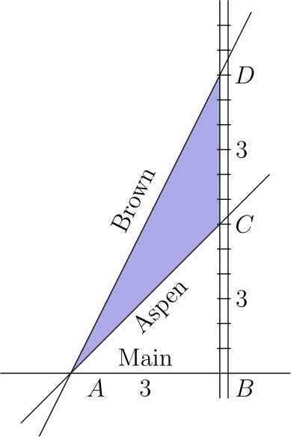
（A）2 （B）3 （C）4.5 （D）6 （E）9
English
The triangular plot of land ACD lies between Aspen Road, Brown Road and a railroad. Main Street runs east and west, and the railroad runs north and south. The numbers in the diagram indicate distances in miles. The width of the railroad track can be ignored. How many square miles are in the plot of land ACD?
(A) 2 (B) 3 (C) 4.5 (D) 6 (E) 9
第 8 题
一个长方形的长增加 10%，宽减少 10%。新面积是原面积的百分之多少？
（A）90 （B）99 （C）100 （D）101 （E）110
English
The length of a rectangle is increased by 10% and the width is decreased by 10%. What percent of the old area is the new area?
(A) 90 (B) 99 (C) 100 (D) 101 (E) 110
第 9 题
在一个等边三角形的一边上作一个正方形。在正方形的一条不相邻的边上作一个正五边形，如图所示。在五边形的一条不相邻的边上作一个正六边形。用同样方式继续作正多边形，直到作出正八边形。所得图形的外边界有多少条边？
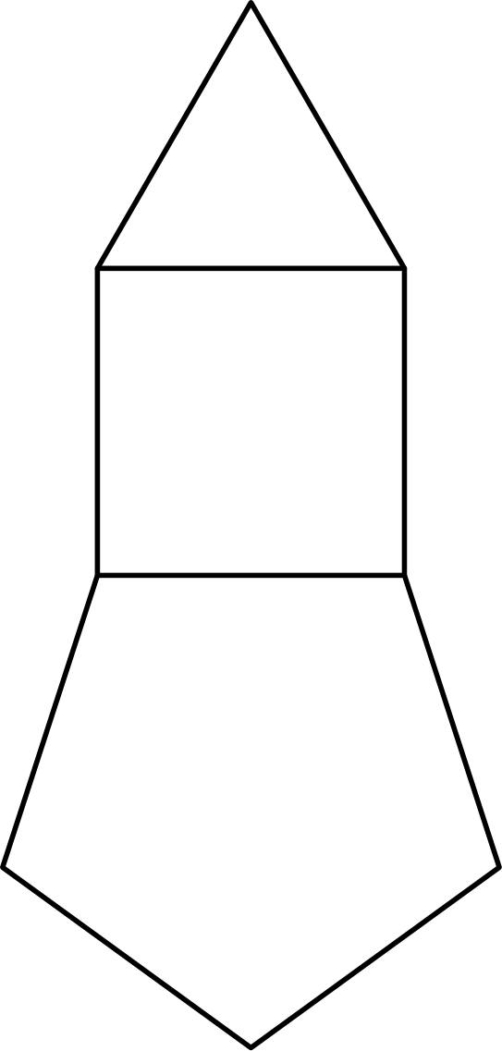
（A）21 （B）23 （C）25 （D）27 （E）29
English
Construct a square on one side of an equilateral triangle. On one non-adjacent side of the square, construct a regular pentagon, as shown. On a non-adjacent side of the pentagon, construct a regular hexagon. Continue to construct regular polygons in the same way, until you construct an octagon. How many sides does the resulting polygon have?
(A) 21 (B) 23 (C) 25 (D) 27 (E) 29
第 10 题
在一个由 64 个单位正方形组成的棋盘上，随机选择一个单位正方形。所选正方形<b>不</b>接触棋盘外边缘的概率是多少？
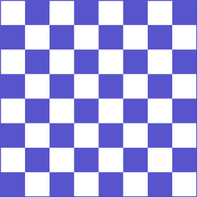
（A）1/16 （B）7/16 （C）1/2 （D）9/16 （E）49/64
English
On a checkerboard composed of 64 unit squares, what is the probability that a randomly chosen unit square does <b>not</b> touch the outer edge of the board?
(A) 1/16 (B) 7/16 (C) 1/2 (D) 9/16 (E) 49/64
第 11 题
阿马科中学的书店出售铅笔，每支铅笔价格为整数美分。一些七年级学生每人买了一支铅笔，总共支付 1.43 美元。30 名六年级学生中的一些人每人买了一支铅笔，总共支付 1.95 美元。买铅笔的六年级学生比七年级学生多多少人？
（A）1 （B）2 （C）3 （D）4 （E）5
English
The Amaco Middle School bookstore sells pencils costing a whole number of cents. Some seventh graders each bought a pencil, paying a total of 1.43 dollars. Some of the 30 sixth graders each bought a pencil, and they paid a total of 1.95 dollars. How many more sixth graders than seventh graders bought a pencil?
(A) 1 (B) 2 (C) 3 (D) 4 (E) 5
第 12 题
如图所示的两个转盘各转一次，并各自落在一个编号扇区上。两个扇区中的数字之和为质数的概率是多少？
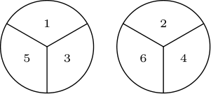
（A）1/2 （B）2/3 （C）3/4 （D）7/9 （E）5/6
English
The two spinners shown are spun once and each lands on one of the numbered sectors. What is the probability that the sum of the numbers in the two sectors is prime?
(A) 1/2 (B) 2/3 (C) 3/4 (D) 7/9 (E) 5/6
第 13 题
一个三位整数包含数字 1、3、5 各一次。这个整数能被 5 整除的概率是多少？
（A）1/6 （B）1/3 （C）1/2 （D）2/3 （E）5/6
English
A three-digit integer contains one of each of the digits 1, 3, and 5. What is the probability that the integer is divisible by 5?
(A) 1/6 (B) 1/3 (C) 1/2 (D) 2/3 (E) 5/6
第 14 题
奥斯汀和坦普尔相距 50 英里，由 35 号州际公路相连。邦妮从奥斯汀开车到她女儿在坦普尔的家，平均速度为每小时 60 英里。她把车留给女儿后，沿同一路线坐公交车返回奥斯汀，返程平均速度为每小时 40 英里。整个往返行程的平均速度是多少英里每小时？
（A）46 （B）48 （C）50 （D）52 （E）54
English
Austin and Temple are 50 miles apart along Interstate 35. Bonnie drove from Austin to her daughter’s house in Temple, averaging 60 miles per hour. Leaving the car with her daughter, Bonnie rode a bus back to Austin along the same route and averaged 40 miles per hour on the return trip. What was the average speed for the round trip, in miles per hour?
(A) 46 (B) 48 (C) 50 (D) 52 (E) 54
第 15 题
一份可做 5 份热巧克力的食谱需要 2 块巧克力、1/4 杯糖、1 杯水和 4 杯牛奶。乔丹有 5 块巧克力、2 杯糖、很多水和 7 杯牛奶。如果她保持相同的配料比例，最多能做多少份热巧克力？
（A）5 1/8 （B）6 1/4 （C）7 1/2 （D）8 3/4 （E）9 7/8
English
A recipe that makes 5 servings of hot chocolate requires 2 squares of chocolate, 1/4 cup sugar, 1 cup water and 4 cups milk. Jordan has 5 squares of chocolate, 2 cups of sugar, lots of water, and 7 cups of milk. If she maintains the same ratio of ingredients, what is the greatest number of servings of hot chocolate she can make?
(A) 5 1/8 (B) 6 1/4 (C) 7 1/2 (D) 8 3/4 (E) 9 7/8
第 16 题
有多少个 3 位正整数，其各位数字的乘积等于 24？
（A）12 （B）15 （C）18 （D）21 （E）24
English
How many 3-digit positive integers have digits whose product equals 24?
(A) 12 (B) 15 (C) 18 (D) 21 (E) 24
第 17 题
正整数 x 和 y 是满足下列条件的两个最小正整数：360 与 x 的乘积是平方数，且 360 与 y 的乘积是立方数。x 与 y 的和是多少？
（A）80 （B）85 （C）115 （D）165 （E）610
English
The positive integers x and y are the two smallest positive integers for which the product of 360 and x is a square and the product of 360 and y is a cube. What is the sum of x and y?
(A) 80 (B) 85 (C) 115 (D) 165 (E) 610
第 18 题
图中表示一个 7 英尺乘 7 英尺的地板，由面积为 1 平方英尺的阴影瓷砖和非阴影瓷砖铺成。注意四个角是非阴影瓷砖。如果一个 15 英尺乘 15 英尺的地板也按同样方式铺，需要多少块非阴影瓷砖？
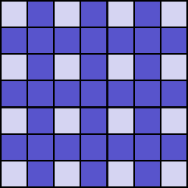
（A）49 （B）57 （C）64 （D）96 （E）126
English
The diagram represents a 7-foot-by-7-foot floor that is tiled with 1-square-foot shaded tiles and unshaded tiles. Notice that the corners have unshaded tiles. If a 15-foot-by-15-foot floor is to be tiled in the same manner, how many unshaded tiles will be needed?
(A) 49 (B) 57 (C) 64 (D) 96 (E) 126
第 19 题
一个等腰三角形的两个角分别为 70° 和 x°。x 的三个可能值之和是多少？
（A）95 （B）125 （C）140 （D）165 （E）180
English
Two angles of an isosceles triangle measure 70° and x°. What is the sum of the three possible values of x?
(A) 95 (B) 125 (C) 140 (D) 165 (E) 180
第 20 题
从下方阵列中的八个点里选三个点作为顶点，可以形成多少个不全等三角形？

（A）5 （B）6 （C）7 （D）8 （E）9
English
How many non-congruent triangles have vertices at three of the eight points in the array shown below?
(A) 5 (B) 6 (C) 7 (D) 8 (E) 9
第 21 题
安迪和贝瑟妮有一个 40 行 75 列的数字矩形阵列。安迪把每一行的数相加，他得到的 40 个行和的平均数是 A。贝瑟妮把每一列的数相加，她得到的 75 个列和的平均数是 B。A/B 的值是多少？
（A）64/225 （B）8/15 （C）1 （D）15/8 （E）225/64
English
Andy and Bethany have a rectangular array of numbers with 40 rows and 75 columns. Andy adds the numbers in each row. The average of his 40 sums is A. Bethany adds the numbers in each column. The average of her 75 sums is B. What is the value of A/B?
(A) 64/225 (B) 8/15 (C) 1 (D) 15/8 (E) 225/64
第 22 题
从 1 到 1000 之间，有多少个整数<b>不</b>含数字 1？
（A）512 （B）648 （C）720 （D）728 （E）800
English
How many whole numbers between 1 and 1000 do <b>not</b> contain the digit 1?
(A) 512 (B) 648 (C) 720 (D) 728 (E) 800
第 23 题
在学校最后一天，旺德福老师给班上的学生发果冻豆。她给每个男生的果冻豆数等于班上男生人数；给每个女生的果冻豆数等于班上女生人数。她带了 400 颗果冻豆，发完后剩下六颗。班上男生比女生多两人。她班上有多少名学生？
（A）26 （B）28 （C）30 （D）32 （E）34
English
On the last day of school, Mrs. Wonderful gave jelly beans to her class. She gave each boy as many jelly beans as there were boys in the class. She gave each girl as many jelly beans as there were girls in the class. She brought 400 jelly beans, and when she finished, she had six jelly beans left. There were two more boys than girls in her class. How many students were in her class?
(A) 26 (B) 28 (C) 30 (D) 32 (E) 34
第 24 题
字母 A、B、C、D 表示互不相同的数字。如果 A B；+ C A；hline D A 且 A B；- C A；hline A，那么 D 表示哪个数字？
（A）5 （B）6 （C）7 （D）8 （E）9
English
The letters A, B, C and D all represent different digits. If A B；+ C A；hline D A and A B；- C A；hline A, what digit does D represent?
(A) 5 (B) 6 (C) 7 (D) 8 (E) 9
第 25 题
一个体积为一立方英尺的立方体被三次平行于顶面的切割分成四块。第一刀距离顶面 1/2 英尺。第二刀在第一刀下方 1/3 英尺处，第三刀在第二刀下方 1/17 英尺处。从上到下四块标为 A、B、C、D。然后按 C、B、A、D 的顺序首尾相接粘在一起，形成如图所示的长立体。这个立体的总表面积是多少平方英尺？
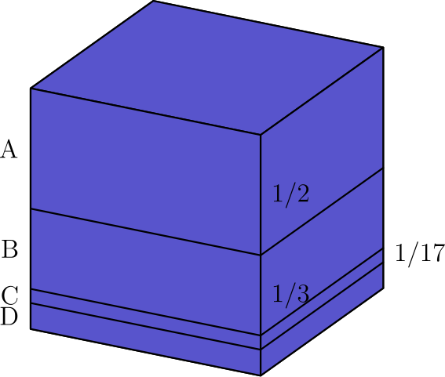
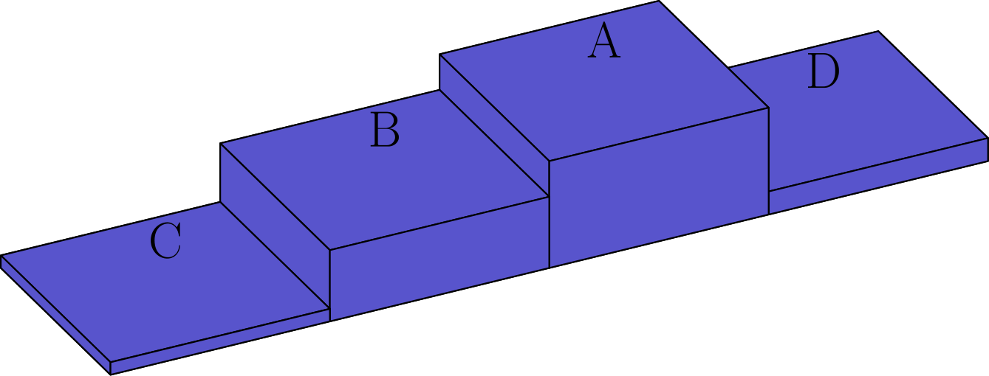
（A）6 （B）7 （C）419/51 （D）158/17 （E）11
English
A one-cubic-foot cube is cut into four pieces by three cuts parallel to the top face of the cube. The first cut is 1/2 foot from the top face. The second cut is 1/3 foot below the first cut, and the third cut is 1/17 foot below the second cut. From the top to the bottom the pieces are labeled A, B, C, and D. The pieces are then glued together end to end in the order C, B, A, D to make a long solid as shown. What is the total surface area of this solid in square feet?
(A) 6 (B) 7 (C) 419/51 (D) 158/17 (E) 11

第二部分 解答
答案速查：
题号 1 2 3 4 5 6 7 8 9
答案 E D C B D A C B B
题号 10 11 12 13 14 15 16 17 18
答案 D D D B B D D B C
题号 19 20 21 22 23 24 25
答案 D D D D B E E
答案串：EDCBDACBBDDDBBDDBCDDDDBEE
第 1 题 答案 E
可以倒推，从布里奇特自己留下的 4 个苹果开始。加上她给凯茜的 3 个苹果，这一半共有 7 个苹果。
因为她把原来苹果的一半给了安，所以再乘以 2。7 · 2 = 14，因此布里奇特一开始有 14 个苹果。
所以正确答案是 <b>E</b>。
English
We can work backwards, starting with the 4 apples that Bridget kept for herself. Adding the 3 apples that she gave Cassie, she now has 7 apples.
Finally, we multiply this value by 2 since she gave half of her initial apples to Ann. 7 · 2 = 14, so Bridget started off with 14 apples.
Thus, <b>E</b> is the correct answer.
第 2 题 答案 D
列出比例 4/7 = 28/x。交叉相乘得 4x = 7 · 28 因而 x = 49。
所以正确答案是 <b>D</b>。
English
Set up the proportion 4/7 = 28/x. Cross-multiplying gives 4x = 7 · 28 and hence x = 49.
Thus, <b>D</b> is the correct answer.
第 3 题 答案 C
从图中可知，苏珊娜骑了 3 英里，用时 15 分钟。因此在 30 分钟内，她会骑 6 英里。
所以正确答案是 <b>C</b>。
English
From the graph, we can see that Suzanna rides 3 miles in 15 minutes. This means that in 30 minutes, she will have ridden 6 miles.
Thus, <b>C</b> is the correct answer.
第 4 题 答案 B
注意选项 <b>B</b> 中没有任何长 5 个方格的连续线段。这说明那块长 5 个方格的拼片无法放入该图形。
所以正确答案是 <b>B</b>。
English
Note that option <b>B</b> does not have any segments in it that are 5 blocks long. This means that it is impossible to arrange the 5 block long piece to fit within the figure.
Thus, <b>B</b> is the correct answer.
第 5 题 答案 D
数列开始为 1、2、3。
接下来的项为 1+2+3=6、2+3+6=11、3+6+11=20、6+11+20=37、11+20+37=68。
所以正确答案是 <b>D</b>。
English
The sequence begins 1, 2, 3.
The next terms are 1+2+3=6, 2+3+6=11, 3+6+11=20, 6+11+20=37, and 11+20+37=68.
Thus, <b>D</b> is the correct answer.
第 6 题 答案 A
4 根水管合起来每分钟注入 2.5 · 4 = 10 加仑水。
要注满 24,000 加仑，水管需要 24,000 ÷ 10 = 2,400 分钟。
2,400 分钟等于 2,400 ÷ 60 = 40 小时。
所以正确答案是 <b>A</b>。
English
The 4 hoses together fill the pool with 2.5 · 4 = 10 gallons of water per minute.
To fill 24,000 gallons, it will take the hoses 24,000 ÷ 10 = 2,400 minutes to fill the pool.
2,400 minutes is the same as 2,400 ÷ 60 = 40 hours.
Thus, <b>A</b> is the correct answer.
第 7 题 答案 C
三角形 ADC 的底边是 CD，长度为 3。高也是 3。
因此 ADC 的面积为 1/2 · 3 · 3 = 4.5。
所以正确答案是 <b>C</b>。
English
The base of ADC is CD, which is 3. The altitude is 3 as well.
Therefore, the area of ADC is 1/2 · 3 · 3 = 4.5.
Thus, <b>C</b> is the correct answer.
第 8 题 答案 B
设原来的长和宽为 l 和 w，则原面积为 lw。
新的长为 1.1l，新的宽为 0.9w。因此新面积为 1.1·0.9lw=0.99lw。
这说明新面积是原面积的 99%。
所以正确答案是 <b>B</b>。
English
Let the old length and width be l and w, so the old area is lw.
The new length is 1.1l, and the new width is 0.9w. Thus the new area is 1.1·0.9lw=0.99lw.
This shows that the new area is 99% of the old area.
Thus, <b>B</b> is the correct answer.
第 9 题 答案 B
三角形和八边形在链的两端，所以各有一条边成为共享边而不在外边界上。正方形、五边形、六边形和七边形在中间，所以各有两条边成为共享边。
所得图形有 (3-1)+(4-2) +(5-2)+(6-2) +(7-2)+(8-1)=23 条边。
所以正确答案是 <b>B</b>。
English
The triangle and octagon are at the ends of the chain, so each loses one side to a shared edge. The square, pentagon, hexagon, and heptagon are in the middle, so each loses two sides to shared edges.
The resulting polygon has (3-1)+(4-2) +(5-2)+(6-2) +(7-2)+(8-1)=23 sides.
Thus, <b>B</b> is the correct answer.
第 10 题 答案 D
内部正方形共有 (8 - 2)² = 6² = 36 个。
因此选中其中一个的概率是 36/64 = 9/16。
所以正确答案是 <b>D</b>。
English
There are (8 - 2)² = 6² = 36 squares on the interior.
This means that the probability of choosing one of these squares is 36/64 = 9/16.
Thus, <b>D</b> is the correct answer.
第 11 题 答案 D
买铅笔的七年级学生人数等于 143 除以一支铅笔的价格。同样，买铅笔的六年级学生人数等于 195 除以一支铅笔的价格。
因此铅笔价格同时整除 143 和 195。质因数分解得 143 = 11 · 13 和 195 = 3 · 5 · 13。同时整除 143 和 195 的正整数只有 1 和 13。
如果一支铅笔价格是 1 美分，那么会有 195 名六年级学生买铅笔，这是不可能的。因此一支铅笔价格是 13 美分。
于是 143 ÷ 13 = 11 名七年级学生买铅笔，195 ÷ 13 = 15 名六年级学生买铅笔。所以六年级学生比七年级学生多 4 人。
所以正确答案是 <b>D</b>。
English
The number of seventh graders that bought a pencil is 143 divided by the price of a pencil. Similarly, the number of sixth graders that bought a pencil is 195 divided by the price of a pencil.
This means that the price of a pencil divides both 143 and 195. Prime factorizing, we get 143 = 11 · 13 and 195 = 3 · 5 · 13. The only numbers that divide both 143 and 195 are 1 and 13.
If 1 cent was the price of the pencil, that means 195 sixth graders bought pencils, which is not possible. Therefore, the price of a pencil is 13 cents.
This means that 143 ÷ 13 = 11 seventh graders bought a pencil, and 195 ÷ 13 = 15 sixth graders bought a pencil. Therefore, 4 more sixth graders than seventh graders bought pencils.
Thus, <b>D</b> is the correct answer.
第 12 题 答案 D
可以求出每种可能结果中两个数字的和。
1 + 2 = 3 1 + 4 = 5 1 + 6 = 7 3 + 2 = 5 3 + 4 = 7 3 + 6 = 9 5 + 2 = 7 5 + 4 = 9 5 + 6 = 11。
只有 2 个结果的和不是质数，也就是和为 9 的两种情况。因此和为质数的概率是 7/9。
所以正确答案是 <b>D</b>。
English
We can find the sum of the two numbers in every possible outcome.
1 + 2 = 3 1 + 4 = 5 1 + 6 = 7 3 + 2 = 5 3 + 4 = 7 3 + 6 = 9 5 + 2 = 7 5 + 4 = 9 5 + 6 = 11.
There are only 2 outcomes where the sum is not prime (the two instances when the sum is 9). Therefore, the probability that the sum is prime is 7/9.
Thus, <b>D</b> is the correct answer.
第 13 题 答案 B
这个数以 1、3 或 5 结尾的可能性相同。
只有当末位是 5 时，它才能被 5 整除，概率为 1/3。
所以正确答案是 <b>B</b>。
English
The number is equally likely to end in 1, 3, or 5.
It is divisible by 5 only if the last digit is 5, which happens with probability 1/3.
Thus, <b>B</b> is the correct answer.
第 14 题 答案 B
从奥斯汀到坦普尔用时 50 ÷ 60 = 5/6 小时。从坦普尔到奥斯汀用时 50 ÷ 40 = 5/4 小时。因此往返总时间为 5/6 + 5/4 = 25/12 小时。
往返总路程为 2 · 50 = 100 英里。因此往返平均速度为 100 ÷ 25/12 = 48 英里每小时。
所以正确答案是 <b>B</b>。
English
The trip from Austin to Temple took 50 ÷ 60 = 5/6 hours. The trip from Temple to Austin took 50 ÷ 40 = 5/4 hours. This means that the total time for the round trip was 5/6 + 5/4 = 25/12 hours.
The total distance of the round trip was 2 · 50 = 100 miles. Therefore, the average speed for the round trip was 100 ÷ 25/12 = 48 miles per hour.
Thus, <b>B</b> is the correct answer.
第 15 题 答案 D
需要找出哪种配料是限制因素。
乔丹的巧克力足够做 5÷2=5/2 批，糖足够做 2÷1/4=8 批，牛奶足够做 7÷4=7/4 批。
牛奶是限制因素，所以乔丹可以做 5·7/4=35/4=83/4 份。
所以正确答案是 <b>D</b>。
English
We need to find which ingredient is the limiting factor.
Jordan has enough chocolate for 5÷2=5/2 batches, enough sugar for 2÷1/4=8 batches, and enough milk for 7÷4=7/4 batches.
The milk is limiting, so Jordan can make 5·7/4=35/4=83/4 servings.
Thus, <b>D</b> is the correct answer.
第 16 题 答案 D
小于 10 且乘积为 24 的整数三元组只有 (1, 3, 8), (1, 4, 6), (2, 2, 6)， (2, 3, 4)。
有 3 个数字互不相同的三元组，每个可以重新排列成 6 个不同的 3 位正整数。另一个三元组可以排列成 3 个不同的 3 位正整数。
总数为 3 · 6 + 3 = 21。
所以正确答案是 <b>D</b>。
English
The only triples of integers less than 10 that multiply to 24 are (1, 3, 8), (1, 4, 6), (2, 2, 6), (2, 3, 4).
The triples with 3 distinct numbers can be rearranged to form 6 distinct 3-digit positive integers. The other triple can be arranged to form 3 distinct 3-digit positive integers.
This leaves a total of 3 · 6 + 3 = 21 integers.
Thus, <b>D</b> is the correct answer.
第 17 题 答案 B
一个数是完全平方数时，质因数分解中每个指数都必须是偶数。一个数是立方数时，指数都必须能被 3 整除。
分解 360，得 360 = 2³ · 3² · 5。要让 360x 成为完全平方数且 x 最小，x 必须提供一个因子 2 和一个因子 5。因此可取 x = 10。
要让 360y 成为立方数，y 必须提供一个因子 3 和两个因子 5。因此可取 y = 75，所以 x + y = 85。
所以正确答案是 <b>B</b>。
English
For a number to be a perfect square, every exponent in the prime factorization must be even. For it to be a cube, the exponents must be divisible by 3.
We can factor 360 to get 360 = 2³ · 3² · 5. For 360x to be a perfect square and x to be minimized, x must have one factor of 2 and one factor of 5. Therefore, we can let x = 10.
For 360y to be a cube, y must have one factor of 3 and two factors of 5. Therefore, we can let y = 75, suggesting x + y = 85.
Thus, <b>B</b> is the correct answer.
第 18 题 答案 C
在 7×7 的例子中，有 4 行各含 4 块非阴影瓷砖，所以共有 4²=16 块非阴影瓷砖。
对 15×15 且模式相同的地板，会有 8 行各含 8 块非阴影瓷砖。
因此非阴影瓷砖数为 8²=64。
所以正确答案是 <b>C</b>。
English
In the 7×7 example, there are 4 rows that contain 4 unshaded tiles, for 4²=16 unshaded tiles.
For a 15×15 floor with the same pattern, there will be 8 such rows with 8 unshaded tiles each.
Thus the number of unshaded tiles is 8²=64.
Thus, <b>C</b> is the correct answer.
第 19 题 答案 D
所有可能情形如下图所示。
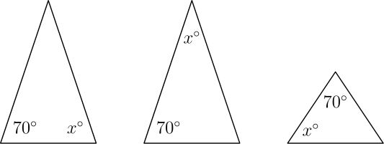
在第一种情形中，由等腰三角形性质可得 x = 70。
在第二种情形中，有 70 · 2 + x = 180，因此 x = 40。
在第三种情形中，有 2x + 70 = 180，因此 x = 55。
这些值之和为 70 + 40 + 55 = 165。
所以正确答案是 <b>D</b>。
English
All the following possibilities are shown below.
In the first scenario, we get x = 70 by the properties of the isosceles triangle.
In the second scenario, we get that 70 · 2 + x = 180, from which we get that x = 40.
From the third scenario, we get that 2x + 70 = 180, from which we get that x = 55.
The sum of these values yields 70 + 40 + 55 = 165.
Thus, <b>D</b> is the correct answer.
第 20 题 答案 D
由对称性，只需列出每种可能三角形形状的一个代表。
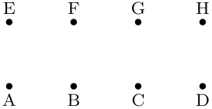
一份完整的不全等三角形代表列表是 ABE、ABG、ACE、ABH、AEH、ACF、ACH 和 ADF。
八个点形成的其他三角形都与这 8 个三角形中的某一个全等。
所以正确答案是 <b>D</b>。
English
By symmetry, it is enough to list one representative of each possible triangle shape.
One complete list of non-congruent possibilities is ABE, ABG, ACE, ABH, AEH, ACF, ACH, and ADF.
Every other triangle formed from the eight points is congruent to one of these 8 triangles.
Thus, <b>D</b> is the correct answer.
第 21 题 答案 D
设 S 是阵列中所有数的和。
安迪的 40 个行和加起来也是 S，所以平均数为 A=S/40。贝瑟妮的 75 个列和加起来也是 S，所以平均数为 B=S/75。
因此 A/B=(S/40)/(S/75)=75/40=15/8。
所以正确答案是 <b>D</b>。
English
Let S be the sum of all numbers in the array.
Andy’s 40 row sums also add to S, so their average is A=S/40. Bethany’s 75 column sums also add to S, so their average is B=S/75.
Therefore A/B=(S/40)/(S/75)=75/40=15/8.
Thus, <b>D</b> is the correct answer.
第 22 题 答案 D
可以按位数分类。
一位数共有 8 个不含数字 1。
两位数共有 8 · 9 = 72 个不含数字 1。
三位数共有 8 · 9 · 9 = 648 个不含数字 1。
因此不含数字 1 的数共有 8 + 72 + 648 = 728 个。
所以正确答案是 <b>D</b>。
English
We can case on the number of digits.
There are 8 one digit numbers excluding 1.
There are 8 · 9 = 72 two digit numbers that lack the digit 1.
There are 8 · 9 · 9 = 648 three digit numbers that do not include 1.
This yields a total of 8 + 72 + 648 = 728 numbers that do not contain the digit 1.
Thus, <b>D</b> is the correct answer.
第 23 题 答案 B
设班上男生人数为 b，女生人数为 g。由题意，b = g + 2。
如果每个男生得到 b 颗果冻豆，那么给所有男生共发出 b² 颗。同样，给所有女生共发出 g² 颗。
因此 b² + g² = 400 - 6 (g + 2)² + g² = 394 2g² + 4g + 4 = 394 g² + 2g - 195 = 0 (g + 15)(g - 13) = 0。因为 g 不能为负，所以 g = 13。这意味着 b = 15，所以 b + g = 28。
所以正确答案是 <b>B</b>。
English
Let b be the number of boys in the class and g be the number of girls. From the problem, we get that b = g + 2.
If each boy gets b jelly beans, then Mrs. Wonderful will give out a total of b² jelly beans to all the boys. Similarly, she will give out g² jelly beans to all the girls.
Therefore, b² + g² = 400 - 6 (g + 2)² + g² = 394 2g² + 4g + 4 = 394 g² + 2g - 195 = 0 (g + 15)(g - 13) = 0. Since g cannot be negative, we get that g = 13. This means that b = 15, so b + g = 28.
Thus, <b>B</b> is the correct answer.
第 24 题 答案 E
从加法的个位可知，A+B 的个位仍是 A，所以 B=0。
在减法 AB-CA=A 中，现在有 A0-CA=A。个位必须借位，所以 10-A=A，得 A=5。
于是 50-C5=5，所以 C=4。在加法中，50+45=95，所以 D=9。
所以正确答案是 <b>E</b>。
English
From the ones column of the addition, A+B ends in A, so B=0.
In the subtraction AB-CA=A, we now have A0-CA=A. The ones column requires a borrow, so 10-A=A, giving A=5.
Then 50-C5=5, so C=4. In the addition, 50+45=95, so D=9.
Thus, <b>E</b> is the correct answer.
第 25 题 答案 E
从六个坐标方向观察这个立体。
从任一端观察时，外露竖直面的总高度等于 A 块的厚度，即 1/2 英尺。因此每个端向视图的面积为 1/2 平方英尺。
从每个侧面看，四块拼成原单位立方体的侧视图，所以每个侧视图面积为 1 平方英尺。
从上方和下方看，每个视图都显示四个 1 乘 1 的面，所以每个面积为 4 平方英尺。
总表面积为 1/2+1/2+1+1+4+4=11 平方英尺。
所以正确答案是 <b>E</b>。
English
Look at the solid from the six coordinate directions.
Viewed from either end, the exposed vertical faces have total height equal to the thickness of piece A, namely 1/2 foot. Thus each end view has area 1/2 square foot.
From each side, the four pieces stack to the side view of the original unit cube, so each side view has area 1 square foot.
From the top and bottom, each view shows four 1-by-1 faces, so each has area 4 square feet.
The total surface area is 1/2+1/2+1+1+4+4=11 square feet.
Thus, <b>E</b> is the correct answer.

